
MENISCECTOMY/MENISCAL REPAIR
EXERCISES

- Weight bear as tolerated unless told otherwise by your surgeon.

- MENISCAL REPAIRS HAVE ADDITIONAL PRECAUTIONS: Dr. Denkema, Dr. Jones, and Dr. Wessels: No Weight Bearing Allowed for 6 weeks. *Some exercises below are not allowed with Meniscal Repairs: No Active or Resisted Hamstrings x 6 weeks. You must use the other leg to help bend your knee. If you are having a Meniscal Repair, you should arrange to have supervised Physiotherapy within 2 weeks of surgery.

- Use crutches as needed to mimic as normal walking pattern as possible. When doing stairs: go up with your strong leg first, go down with your weak leg first – this ensures your operated leg is always straight when you have weight on it.

- PRICE:
  - Protect your surgery.
  - Relative rest.
  - Ice your knee. Achieve a sense of coolness-coldness at the skin for 15-20 minutes.
  - Compression with a tensor bandage will help keep the swelling down.
  - Elevation of your leg will also help to reduce swelling.

- If you have any difficulty with the movement or strength of your knee after 2 weeks, seek physiotherapy assistance.

- Please do exercises at least 3 times per day, 5-10 repetitions of each.

EXERCISES (Only do the exercises that you are instructed to do.)

IF ANY EXERCISE CAUSES INCREASED PAIN OR SWELLING, PLEASE DISCONTINUE
AT ONCE AND CONTACT YOUR PHYSIOTHERAPIST OR DOCTOR.

- Ankle Pumps
Bend ankles up and down alternating
feet.



\

3. Quadriceps Strengthening
Lie on your back with a roll under your knee. Tighten your thigh muscle and slowly lift your heel off the bed to
straighten your leg fully. Keep your knee on the roll. Hold 10 seconds. Lower slowly. Repeat
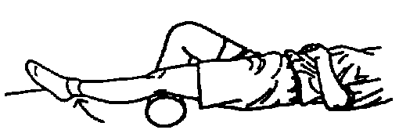
1. Strengthening: Quadriceps sets
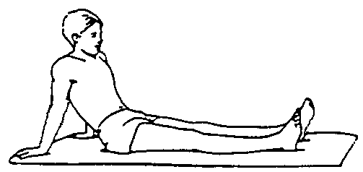
Tighten muscles on top of your thigh by
pushing your knee down into the bed. Hold for 10 seconds.

4. Heel slides *Meniscal Repair, MUST
assist with other leg
Lie on your back. Slide your heel along the bed toward your buttock. Keep your knee pointing up toward the ceiling. Hold 10 seconds. Straighten knee. Repeat.
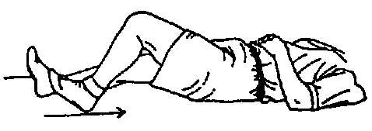
- Straight Leg Raise
Lie on back with your AFFECTED leg straight and the other leg bent. Tighten knee and lift straight leg slowly to level of other knee. After holding 10 seconds, lower slowly. Repeat.
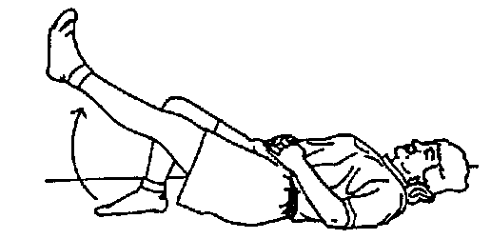

7. Sitting on edge of bed or chair, with both thighs supported. Slowly straighten knee. Hold. Slowly lower.
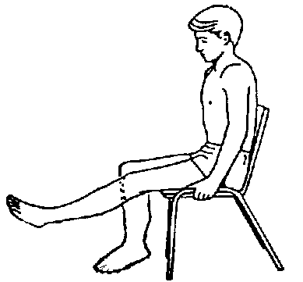

9. Side Leg Lifts
With operated leg on top and bottom leg bent, lift operated leg up toward ceiling. Keep knee pointing straight and leg in line with body. Slowly lower.
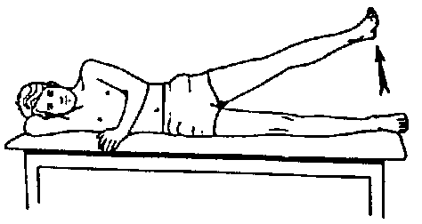

‘

- Squeeze pillow between knees.

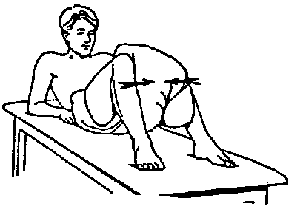

8. Knee Flexion
While sitting in a chair, cross legs at ankle and push operated leg back until stretch is felt. Hold for 10 seconds, SLOWLY return to starting position.

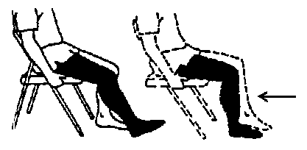

10. Knee Flexion, Prone
*Do not do with Meniscal Repair
Lie on your stomach, and bend your knee toward your buttocks. When stretch is felt, hold for 10 seconds. Slowly lower to the starting position.

