Standard Rehabilitation Wrist Fracture Guidelines
(Operative and Non-Operative Management)
Available at: https://www.ualberta.ca/rehabilitation/research/core/shoulder-and-upper-extremity-research-group-of-edmonton

Please give to patient at the 5-7 week follow-up visit with the surgeon

PHASE 3 - Surgery (weeks 7-8) and No Surgery (weeks 7-8)

- Continue to work on stiff movements 3 times per day from Phase 1 or 2.
- Continue/start grip strengthening exercises as shown in phase 2. If comfortable, start gentle wrist strengthening.

Exercises
Wrist: Sets: 1 | Reps: 10 | 3 times a day |
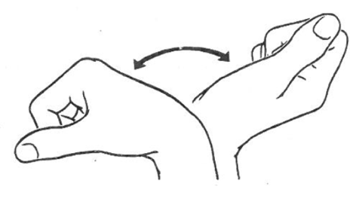 | 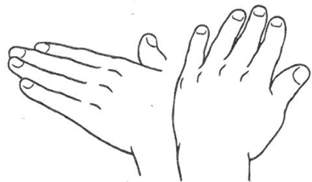
- Bend wrist up and down | - Move hand side to side at the wrist | - Twist palm up and down
Wrist: Sets: 1 | Reps: 10 | Hold: 10-30 sec | 3-5 times a day |
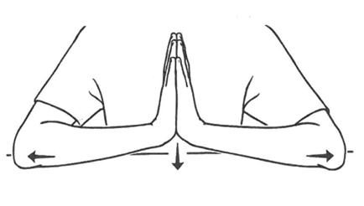 | 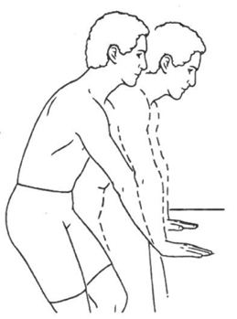
- Place palms together then slowly lower wrists until a stretch is felt | - Rest hand on table. Slowly move body over hands until gentle stretch in wrist. | - Using uninjured hand, turn palm facing upwards

Finger & Thumb: Sets: 1 | Reps: 10 | 3-5 times a day |
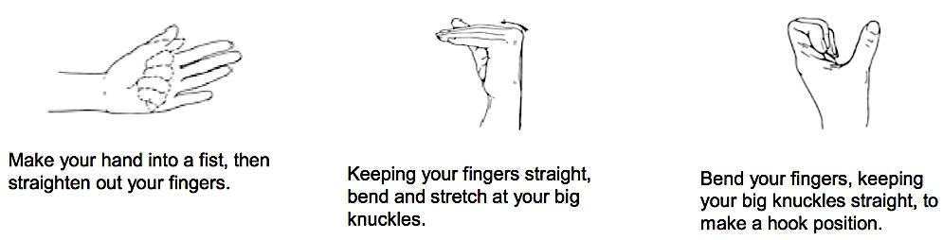 | 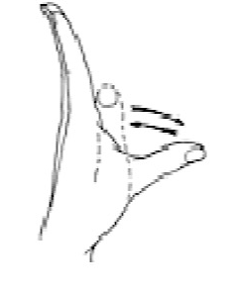
- Make hand into fist, then straighten out | - Reach thumb away from your palm | - Make a hook, bending your fingers keeping big knuckles straight

PHASE 4

Surgery (weeks 8+) and No Surgery (weeks 8+)

- Continue to work on movements and stretches of wrist and hand that are stiff
- Add wrist strengthening
- Consult with your therapist:
  - To ensure exercise are appropriate,
  - Progress your exercises,
  - Guide you to more vigorous activities (e.g. work, sports).
- Use splint to protect wrist in: (1) crowded areas (2) situations where you could fall (slippery ground) if recommended.

Exercises
Wrist: Sets: 3 | Reps: 10 | 1 times a day |
- Holding a weight, bend wrist up and lower down | - Holding a weight, bend wrist up and lower down | - Holidng a hammer, with elbow by waist, twist palm
Wrist: Sets: 3 | Reps: 10 | 1 times a day |
- Squeeze: stress ball, exercise putty or hand gripper | - Holding a weight, bend elbow up and lower down

